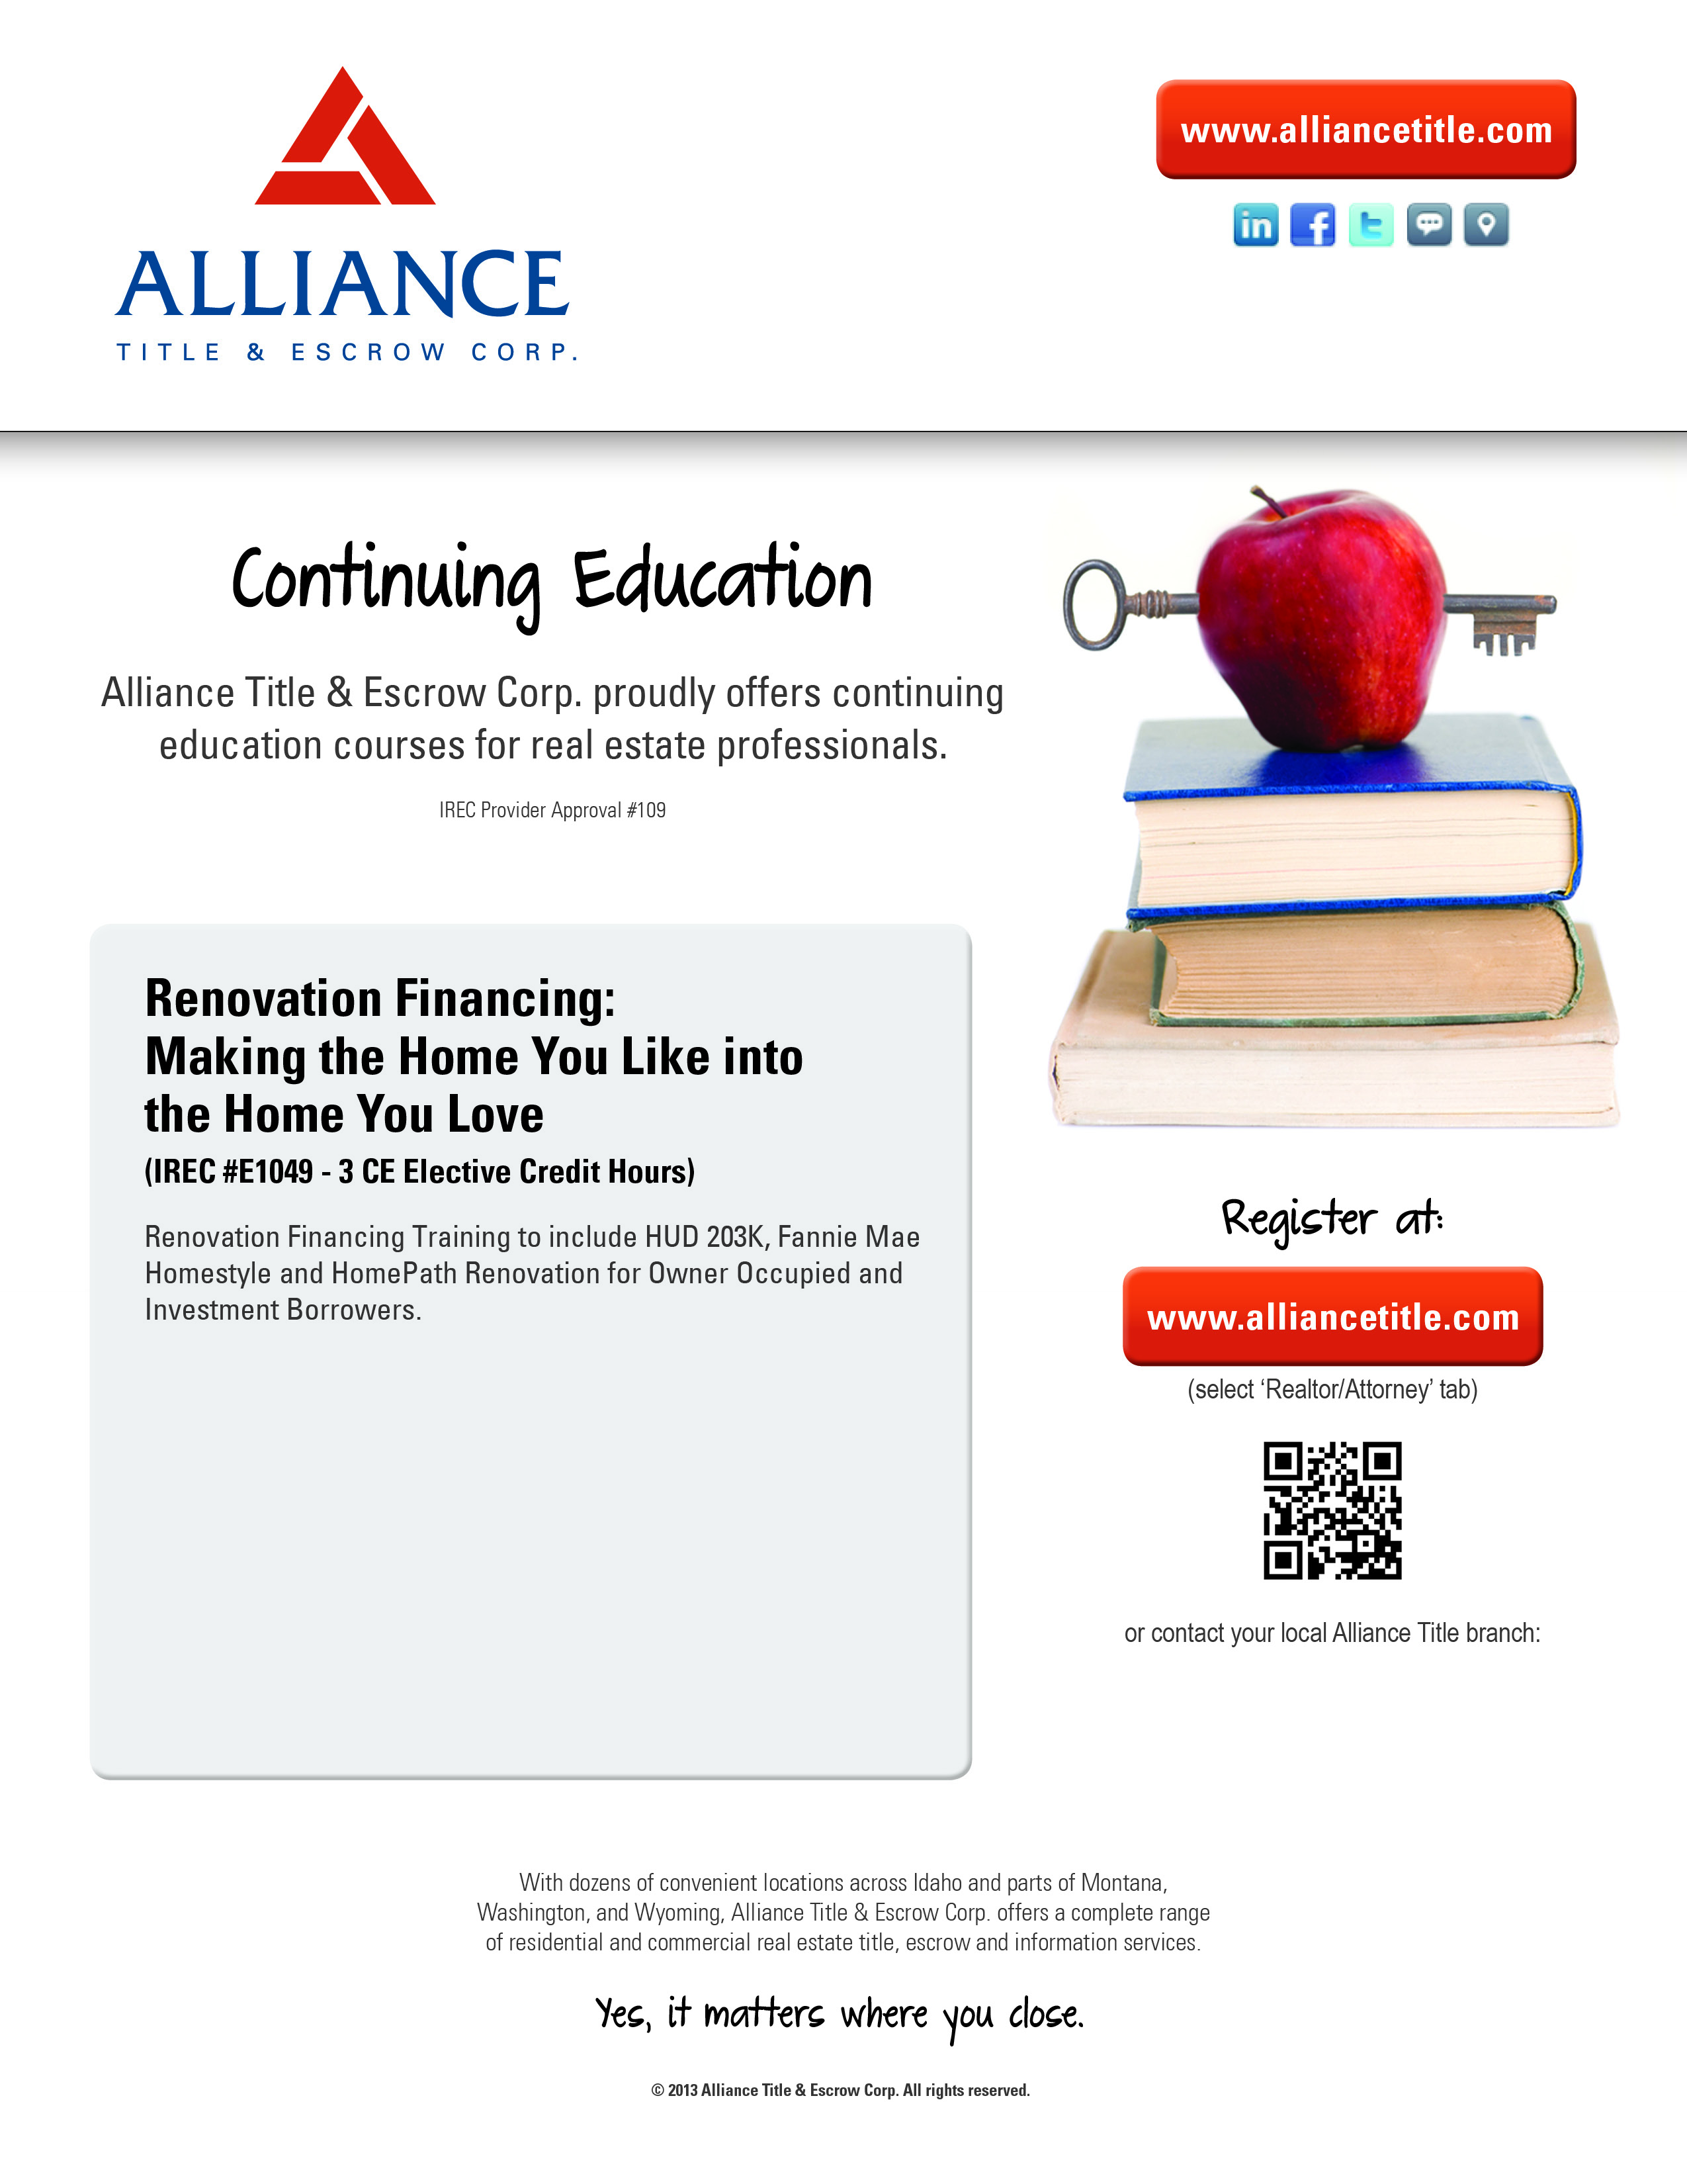

**Thursday, June 5th**

**9:00am – 12:00pm**

Alliance Title & Escrow Corp.

2350 Via Caporatti

Instructor: Bill Young

Course Fee: $15.00

Lisa Armijo: 313-7060

Alliance Title: 232-6163