**Join Us For A Wonderful Lunch While Viewing**

**Some Wonderful University Area Homes**

**Tuesday May 20th**

**11:30-1:00**

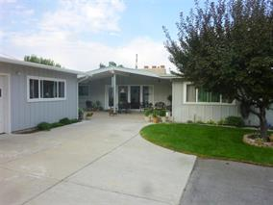

**490 University Dr.**

**Parmesan Chicken, Ceasar Salad, German Potato Salad**

**w/Darsi Johnson- ERA The Brokerage**

**MLS#546873 $325,000**

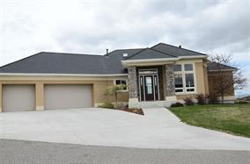

**3500 E. Center**

**Dessert**

**w/ Gloria Howell – Gate City**

**MLS # 548631 $429,900**